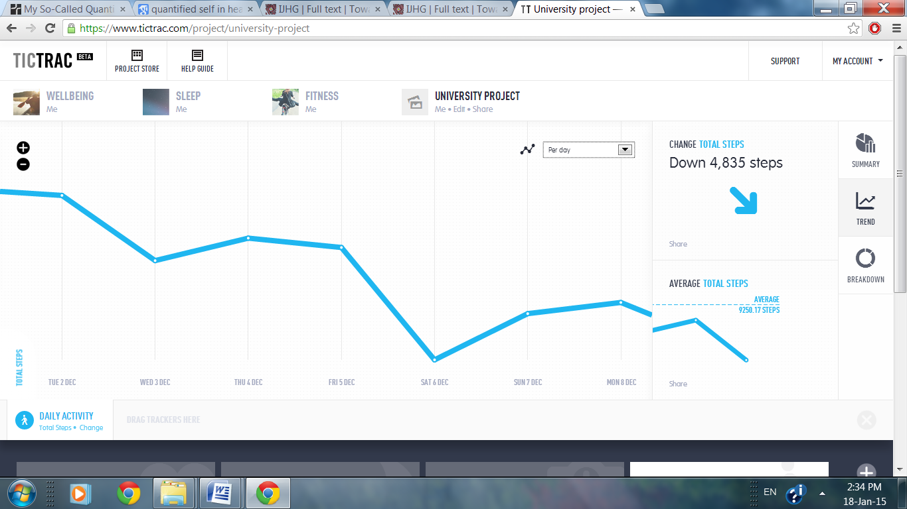
Fig 1. Screenshot of weight trend in Tictrac

